Steps Required ON AWS

1. S3 bucket creation for storing our raw data - \*\*Keep everything default while creation\*\*
2. Creation of IAM policy which will give our EC2 instance access to Kinesis and S3 bucket
   1. Open IAM service and click on Roles THEN Create Role
   2. Select create role for EC2 as shown

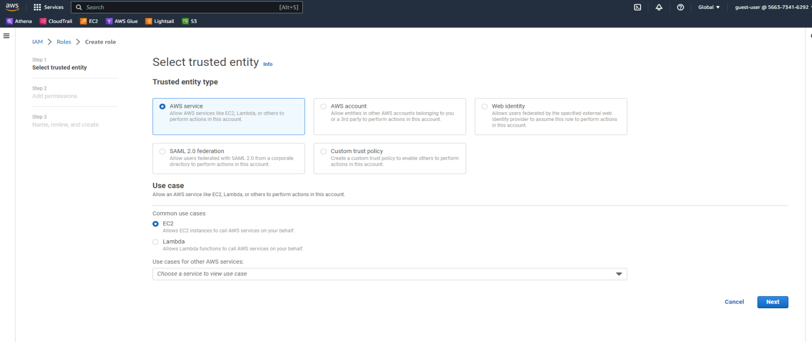

c. Then Select all the Policies which are shown below for your Role

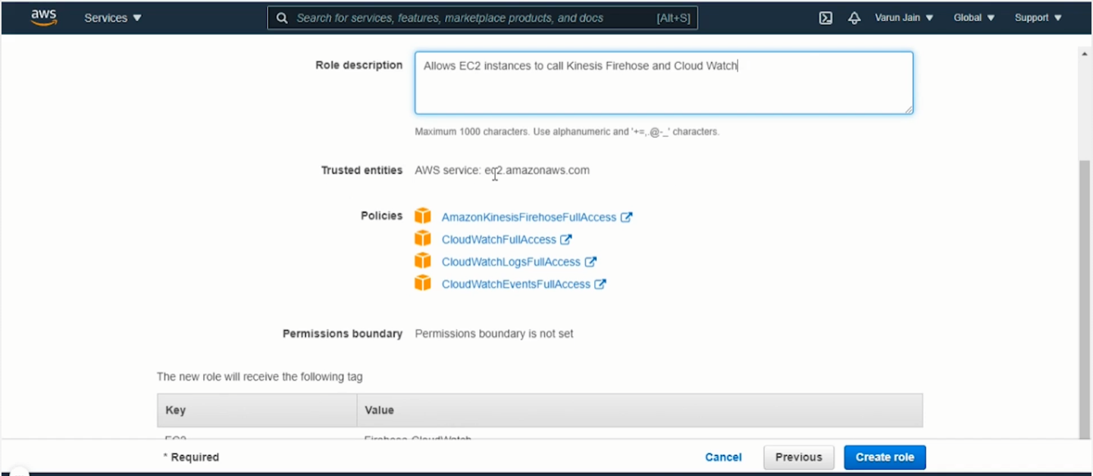

After giving your role a suitable name CLICK, Create Role and your IAM role is configured

1. Setting up your EC2 Instance with configured IAM settings.
   1. Open EC2 in your AWS panel and click on LAUNCH Instance and select the t2.micro instance as shown.   
      MAKE SURE ITS FREE TIER ELIGIBLE as shown below

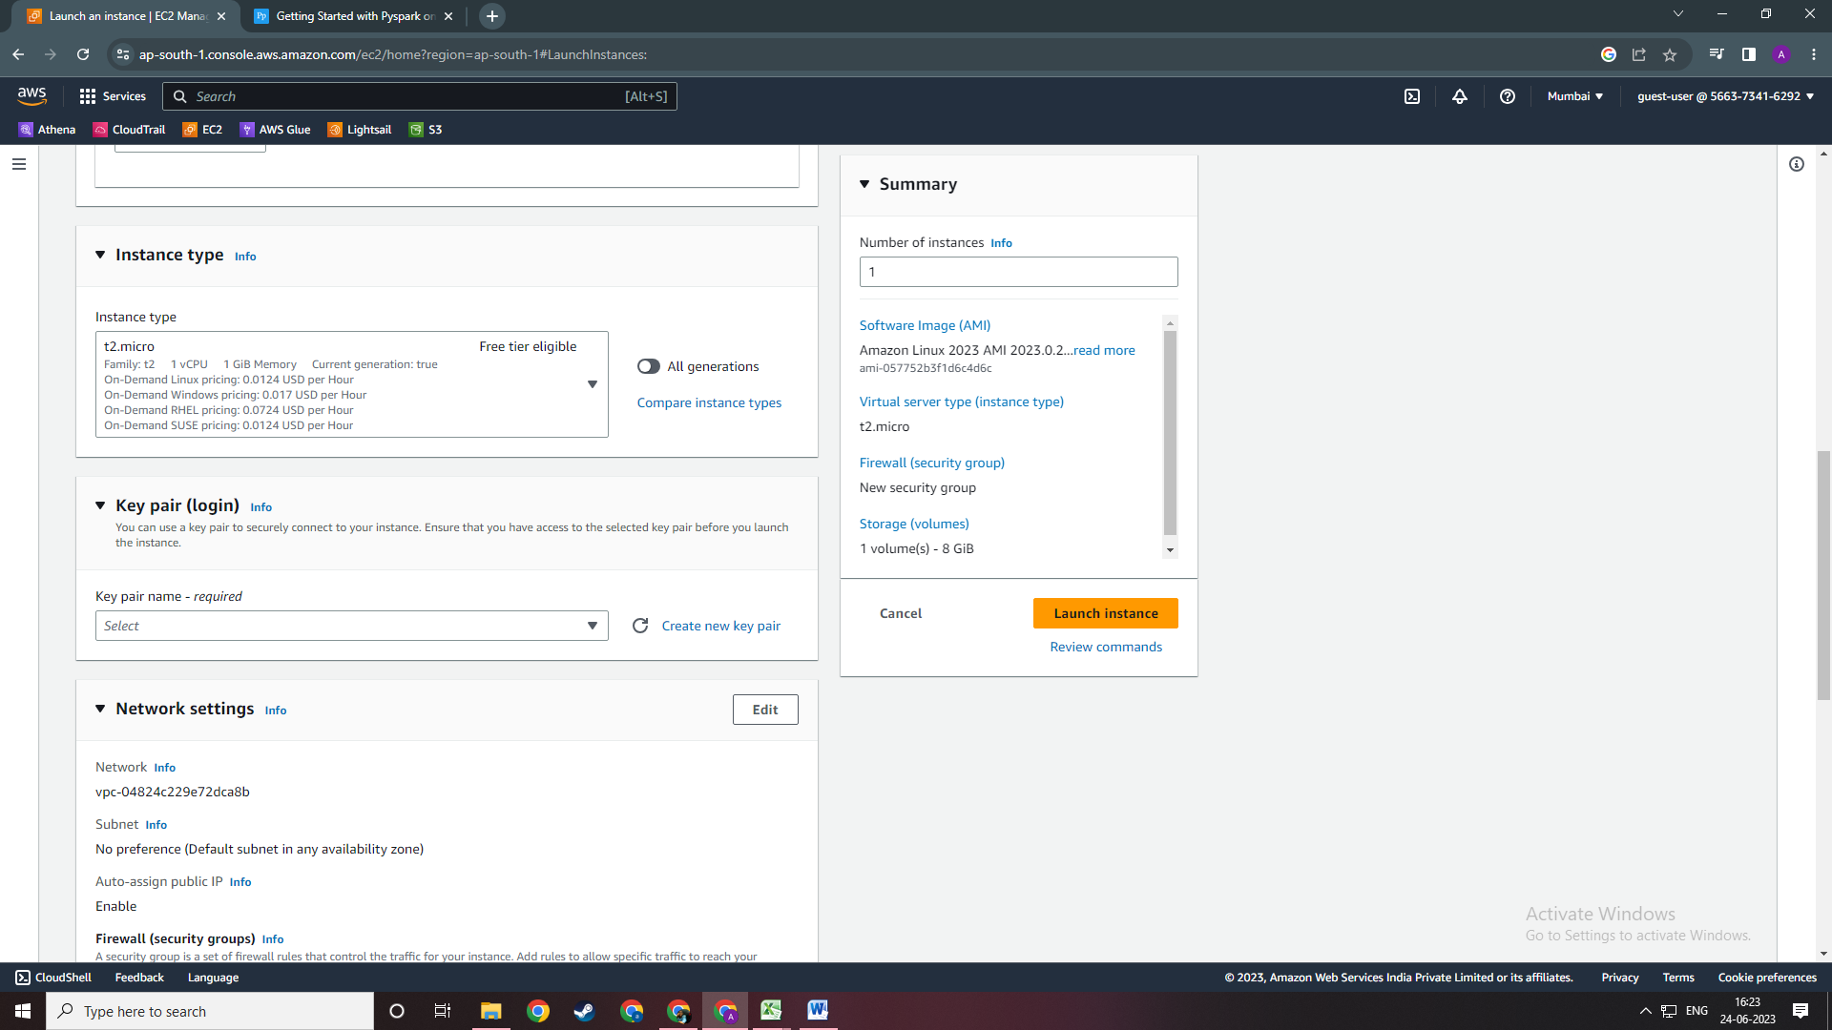

b. Create a New Key pair for our EC2 Instance as shown below.

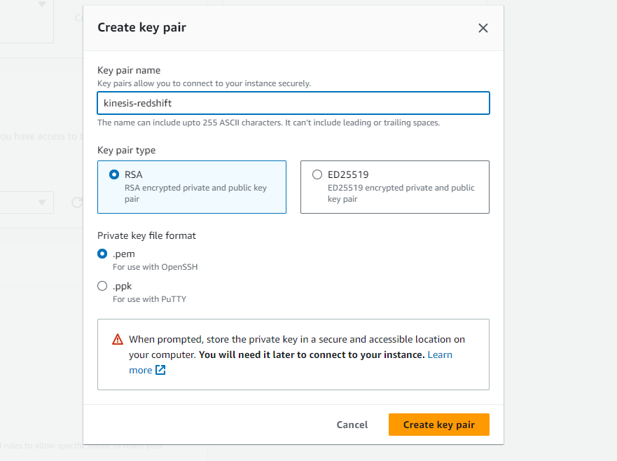

After that Click on Create Key pair. And it will download a pem file which we need to store in the same FOLDER On which we would be working on in your system to connect with EC2.

c. Then in Advance Setting Select the Configured IAM role which we created as shown.   
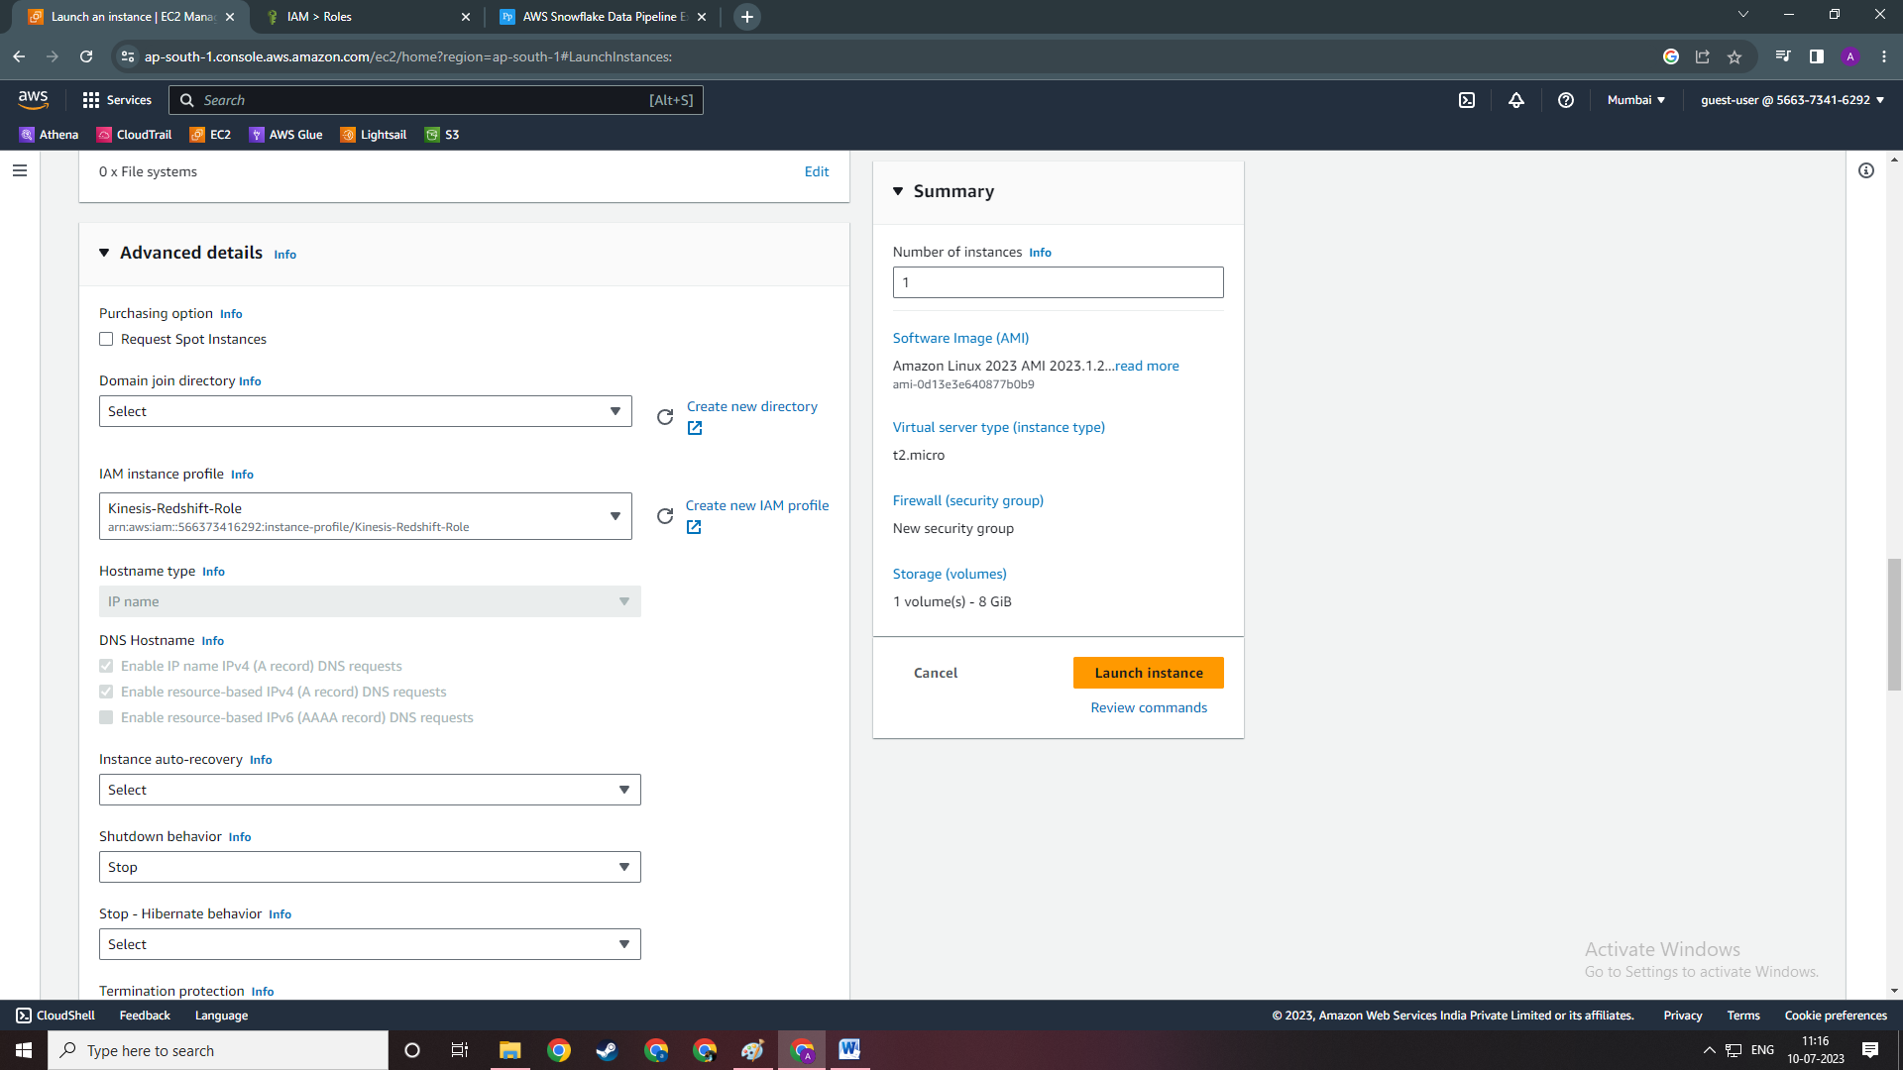

After that just click on LAUNCH instance. DONE